# Watson WeChat – Deployment Instructions

Brannoc Whetter – Cognitive AI

## Overview

This ExpressJS middleware aims to integrate the Watson Assistant Virtual Agent and WeChat messaging platform. The middleware needs to be hosted online (preferably on CloudFoundry) to parse message queries.

For the purposes of demonstration and testing, the WeChat Sandbox is used. Official Accounts can be used if preferred, but setup is far more complicated and out of scope for this document.

## Required Resources

### Accounts

WeChat Account – on [Google PlayStore](https://play.google.com/store/apps/details?id=com.tencent.mm&hl=en) & [Apple AppStore](https://apps.apple.com/au/app/wechat/id414478124)

IBM Cloud Account – [IBM Cloud](https://cloud.ibm.com/)

### Platforms

Watson Assistant – Through IBM Cloud

CloudFoundry – Through IBM Cloud

WeChat Sandbox – [Sandbox](https://mp.weixin.qq.com/debug/cgi-bin/sandbox?t=sandbox/login)

### Technologies

Integration Middleware – [GitHub Repository](https://github.com/BrannocWhetter/wechat-watson-conversation)

IBM Cloud CLI – [CLI Installer](https://cloud.ibm.com/docs/cli/reference/bluemix_cli?topic=cloud-cli-install-ibmcloud-cli#download_install)

### Configuration Keys and Tokens

*These will be input using CloudFoundry Environment Variables and the WeChat Sandbox online interface.*

#### IBM Cloud & Watson

IAM API Key – (e.g. ‘-A123bcdEFG4HIJKLM5NOPq6RsTUV7XYzabCD8eFGhiJ’)

Watson Assistant ID – (e.g. ‘ab1234a56-c7de-8910-1112-131f14567890')

Watson Assistant URL – (e.g. '<https://gateway-syd.watsonplatform.net/assistant/api>') ***//I NEED TO CHANGE THE URL IN CODE TO BE ACCESSED FROM ENVIRONMENT VARIABLES***

AppURL – Your unique CloudFoundry Application URL. Be aware that the default Bluemix URL has connectivity issues. (e.g. ‘<https://watson-wechat.au-syd.mybluemix.net/>’)

#### WeChat

User Token – can be anything as long as it’s the same between platforms (e.g. ‘wechat-token’)

## Deployment Process

### Setup

#### Preliminaries

Before we begin, you need to ensure you have created accounts on both WeChat (through the mobile application) and IBM Cloud.

You also need to have the IBM Cloud CLI Installed. See [CLI Installer](https://cloud.ibm.com/docs/cli/reference/bluemix_cli?topic=cloud-cli-install-ibmcloud-cli#download_install) for more information.

Be aware that when logging in to the CLI with a Federated ID you need to use the login method defined [here](https://cloud.ibm.com/docs/iam?topic=iam-federated_id).

#### Setting up Watson Assistant

Text

1. Log in to IBM Cloud.
2. Search “**Watson Assistant**” in the IBM Cloud Header search bar. Select Watson Assistant.

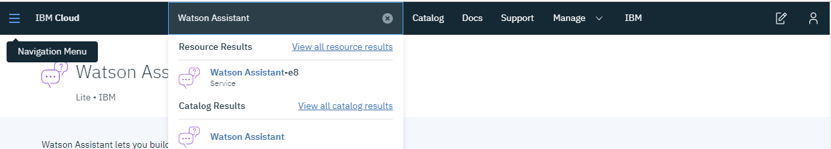

1. Name the service, choose whichever settings best suit you for region and resource group. This project works entirely with just the Lite plan. Other plans can be chosen if necessary. Click Create.

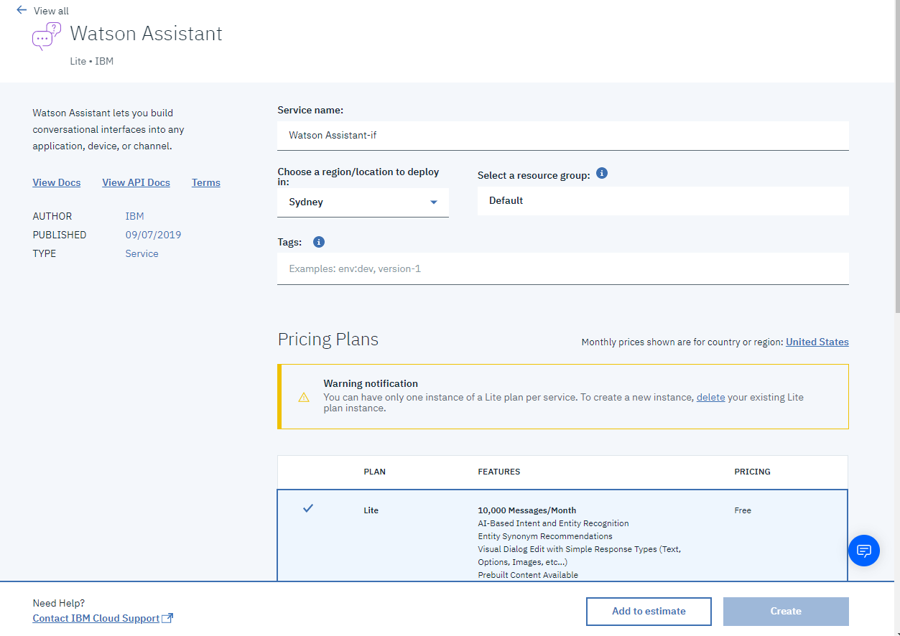

1. Note down the Credentials (API Key and URL) from your new Assistant’s Manage page. If none exist, go to Service credentials and generate a new set.
2. Launch Watson Assistant. Create an Assistant, name it something related to your use case, such as Travel Insurance Bot.
3. Create a new Skill – Select Dialog Skill. Be sure to select the language you wish the bot to use.
4. Set up intents, entities and dialogues. Watson Assistant has prebuilt content and documentation [here](https://cloud.ibm.com/docs/services/assistant?topic=assistant-getting-started#getting-started-tutorial).

Watson Assistant is now set up for integration.

#### Setting up CloudFoundry

Text

1. Log in to IBM Cloud.
2. Search “**SDK for Node.js**” in the IBM Cloud Header search bar. Select SDK for Node.js.

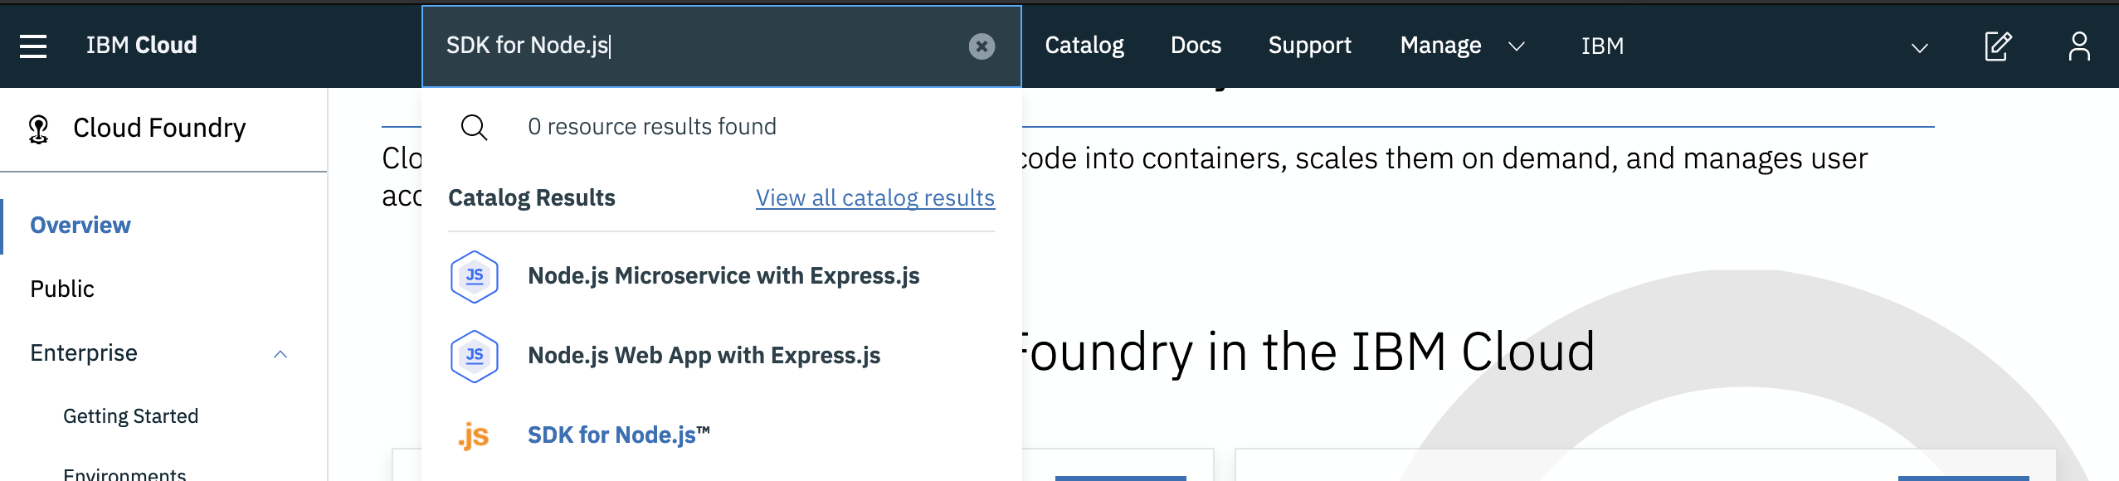

1. Name the service, choose whichever settings best suit you for region and resource group. This project works entirely with just the Lite plan. Other plans can be chosen if necessary. Click Create.

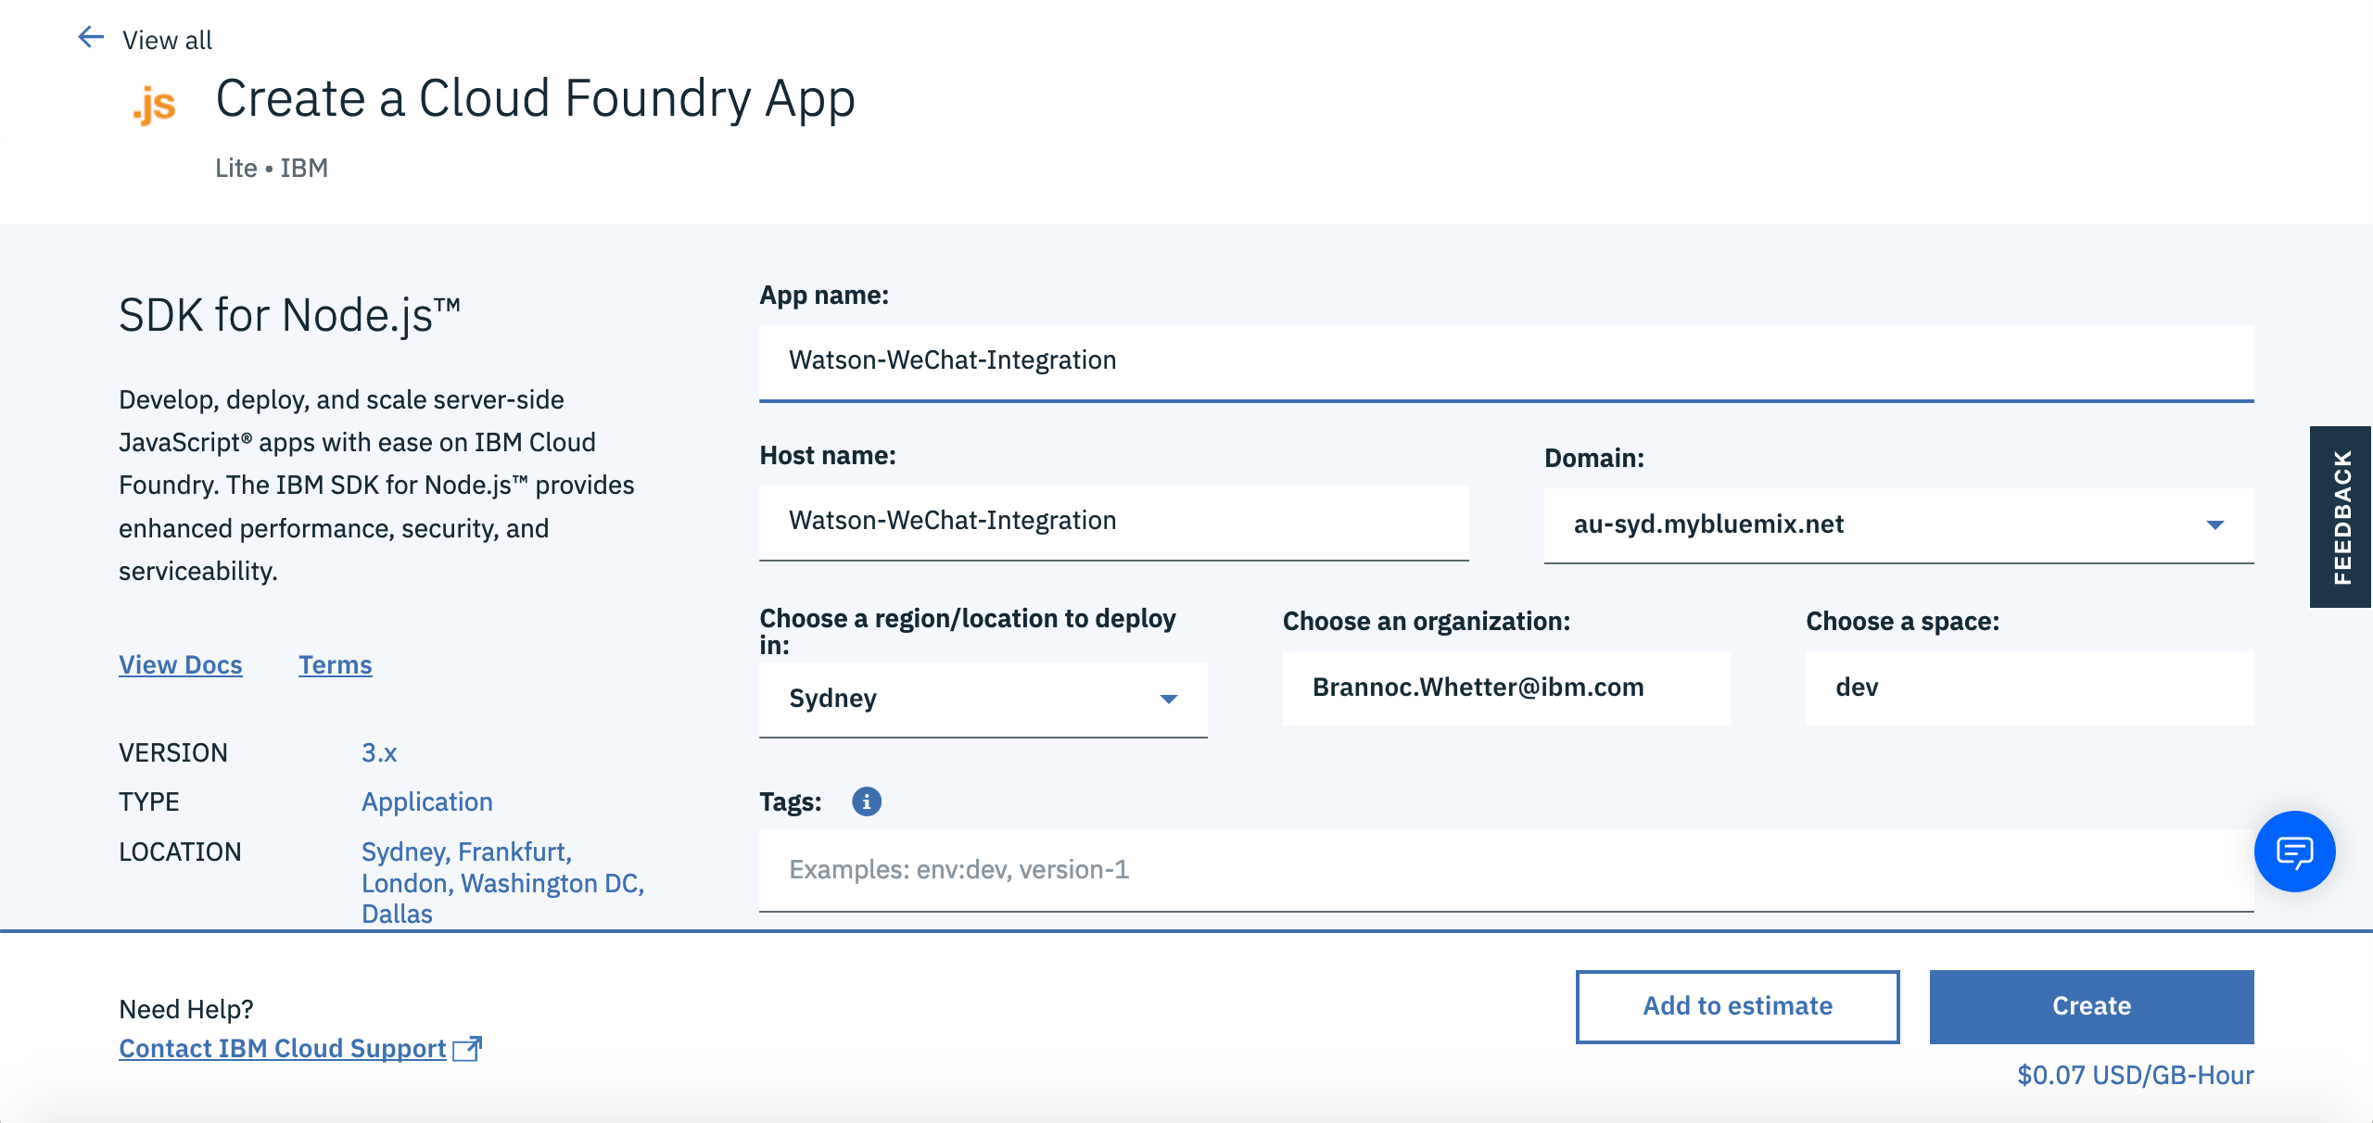

1. From Cloud Foundry dashboard, select ‘Routes’, ‘Edit Routes’. Add a route, enter the same hostname as the original ‘mybluemix.net’ domain and change the domain to one of the others, I use ‘appdomain.cloud’.

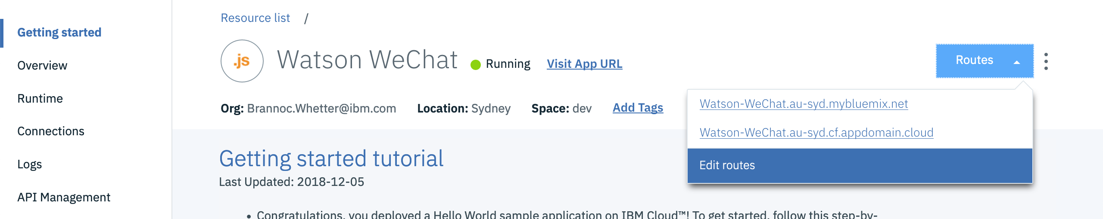

1. Select ‘Runtime’ from the sidebar and access the ‘Environment Variables’ tab. Scroll down to User Defined and add the IAM_API_KEY, WATSON_ASSISTANT_ID and WECHAT_TOKEN. Be sure to save the values. Cloud Foundry should restart automatically, if not select the gear menu and click restart.

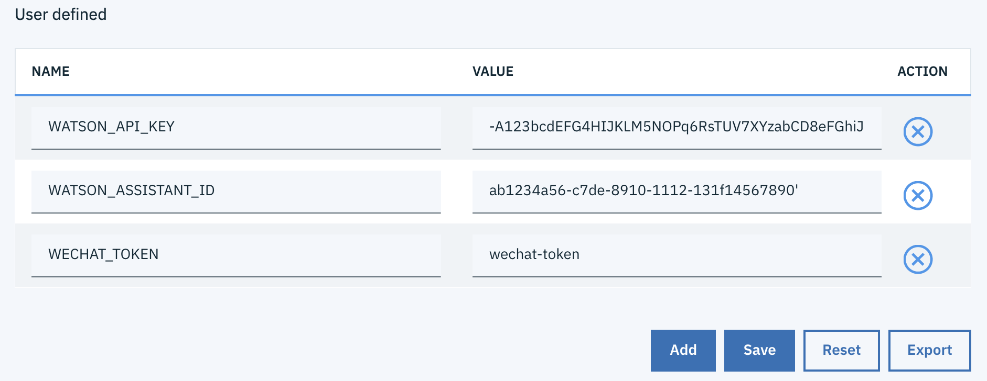

Cloud Foundry is now set up for integration.

#### Setting up WeChat Sandbox

Have your phone at the ready, you will need to use the WeChat Mobile application to complete setup.

1. Select the green WeChat button. It will open a new page with a unique QR Code.



1. Open the WeChat app on your phone, select Discover and choose scan. Scan the QR code and accept the popups. You may need to register your WeChat account with the Sandbox.
2. Deploy the middleware using instructions below. Deployment is required for the following steps to succeed.
3. Input the values for the App URL and the WeChat Token you set during Cloud Foundry setup in their associated slots. Note the App URL is using a non-Bluemix route. Clicking accept should test the connection, a small notification indicates success or failure. If this test fails, ensure that the values are correct and that the middleware has been correctly deployed.

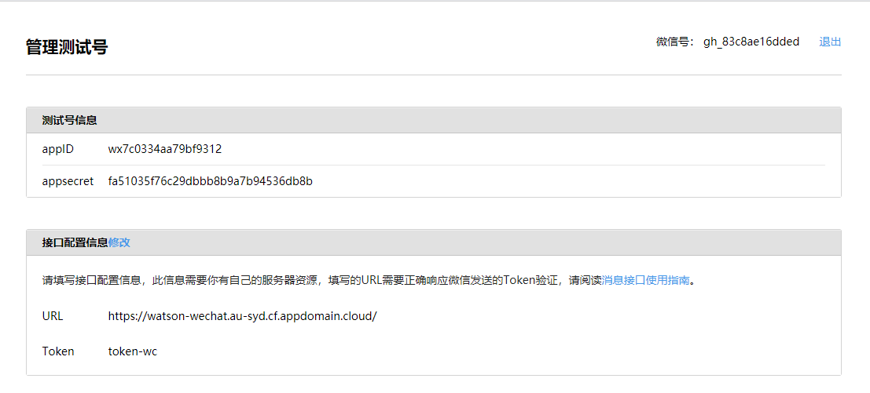

1. In order to access the sandbox from a user environment, you have to add users to your SandBox by scanning another QR code on this page.

WeChat Sandbox is now set up for integration.

##### Steps for Messaging

The Sandbox account is considered an Official Account and is not generally visible in the user interface.

1. Via the WeChat application, select contacts, then official accounts.
2. The application is then accessible with a string of characters as its name.
3. Tap the account and click message. You can now converse with the agent.

Note that you can also download and use the WeChat desktop application, which may be easier when testing.

### Installation and Deployment

#### Deploying Middleware on CloudFoundry

Text

1. Download the [GitHub Repository](https://github.com/BrannocWhetter/wechat-watson-conversation) for the middleware by selecting ‘Clone or Download’ and choosing ‘Download ZIP’.

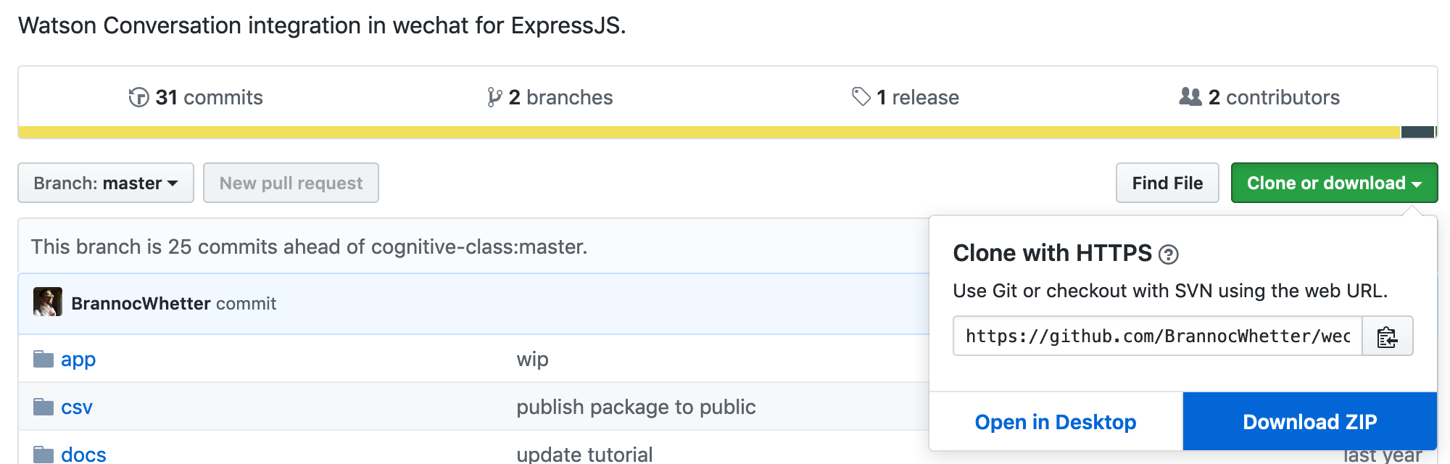

1. Extract the repo into a working folder. Open the IBM Cloud CLI in this folder.
2. In the working directory, locate manifest.yml. Edit the name value to be your Cloud Foundry application name. For example, ‘Watson WeChat’ or ‘WeChat-Watson-Integration'.

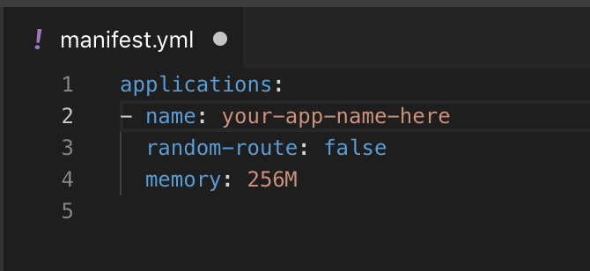

1. Once the Cloud CLI is open in the repo’s working directory, you need to log in with ‘ibmcloud login’ or the federated login method above. You then need to target the associated organisation and space using ‘ibmcloud target --cf’.
2. Next, upload the repository to Cloud Foundry using ‘ibmcloud cf push’.

The middleware is now deployed on Cloud Foundry and the integration is complete.

### Debugging

If you are debugging the tool for any reason, the Cloud Foundry logs are the best place to look. The newest logs are at the bottom.

These logs can also be accessed from the IBM Cloud CLI using ‘ibmcloud cf logs --recent'.

Otherwise, contact Brannoc Whetter or submit an issue to the GitHub repository.